# **THE BYLNK**

A Term Paper / Project Report

Submitted in the partial fulfillment of the requirements for the award of the degree of

# **Bachelor of Technology in**

**Department of Electronics & Communication Engineering**

By

**2110040001-Harish**

**2110040011-Karthik Yadav**

**2110040019- Sai Lakshman Goud**

**2110040040-Vishwas**

**2110040046-Jathin**

**2110040060-Bharath**

under the supervision of

# **Dr Actlin Jeeva M P,**

# Associate Professor



**Department of Electronics & Communication Engineering**

K L E F, Off Campus-Hyderabad,

Aziz Nagar- 500075, Ranga Reddy (Dist.), Telangana, India. April, 2023

**Abstract**

In modern times, owing to hectic schedules it becomes very difficult to remain active all the time. Imagine a situation where a person is driving home from work, dead tired after facing all the challenges of the day. His hands are on the wheel and foot on the pedal but suddenly he starts feeling drowsy, his eyes start shutting and his vision blurs and before he knows it, he’s asleep. Falling asleep on the wheel can lead to serious consequences, there may be accidents and people may even lose their lives. This situation is much more common then we notice and hence, it is very important to counter this problem. So to address this issue, we have come up with a Driver Anti-sleep Device. This system alerts the user if he/she falls asleep at the wheel thereby, avoiding accidents and saving lives. This system is useful especially for people who travel long distances and people who are driving late at night. The circuit is built around Schmitt trigger, timer IC, transistor, a relay and a logic gate. Around half an hour after the reset of timer IC, transistors rive the buzzer to sound an intermediate beep. If timer IC is not reset at that time, around one minute later the output of gate conducts. Due to this the clock stops counting further and relay energizes to deactivate the load. This state changes only reset switch is pressed. As a result of pressing the reset switch a next timer is set which will trigger the same events after half an hour.

**Contents**

**Contents Page No.**

**Chapter1:** Introduction 1

**Chapter2:** Literature Survey 2

**Chapter3:** Requirements 3

**Chapter4:** Methodology 4

**Chapter5:** Theoretical Analysis 5

**Chapter6:** Conclusion 6

**Chapter7:** References 7

**Chapter1: Introduction**

The use of technology in preventing accidents has been a major concern for many industries. With the advancement of technology, we can now prevent accidents in ways that were not possible before. One such innovation is the anti-accident sensor using spects eye sensor. This technology is designed to detect and alert the user of any potential danger in their surroundings.

The anti-accident sensor using spects eye sensor is an innovative technology that uses spects eye sensor to detect and alert the user of any potential danger. This technology is designed to help people who work in hazardous environments or those who are visually impaired.

There are some glasses available in the market that claim to help prevent drowsiness while driving, but their effectiveness is not scientifically proven. As an AI language model, I cannot promote or recommend any specific brand or product. However, I can provide some general information on the subject.

Anti-sleep glasses are typically equipped with sensors that detect changes in head position and alertness levels, and then emit an alarm or vibration to alert the driver when they detect signs of drowsiness. Some models also use blue light therapy, which is believed to stimulate the brain and promote wakefulness.

While these glasses may seem like a convenient solution to prevent drowsy driving, it is important to note that they are not a substitute for getting enough sleep and taking breaks when needed. The best way to prevent drowsy driving is to ensure that you get enough rest before driving, take regular breaks, and avoid driving during times when you are most likely to feel sleepy, such as late at night or early in the morning. If you do feel drowsy while driving, it is important to pull over and rest until you feel alert enough to continue driving safely.

There are a few technologies that can help improve alertness and combat sleepiness, such as:

Light Therapy: This involves exposing oneself to bright light, which can help regulate the body's circadian rhythm and improve alertness. Light therapy can be done using special lamps or devices that emit bright light.

Caffeine: Caffeine is a stimulant that can help improve alertness and cognitive performance. It is found in many drinks such as coffee, tea, and energy drinks.

Exercise: Regular physical activity can help improve alertness and reduce feelings of sleepiness. Exercise can increase blood flow and oxygen to the brain, leading to improved cognitive function.

Naps: Taking a short nap can help reduce feelings of sleepiness and improve cognitive function. A nap of 20-30 minutes can be enough to help recharge the brain.

It is important to note that the best way to combat sleepiness is to get enough sleep on a regular basis. The National Sleep Foundation recommends that adults get 7-9 hours of sleep each night.

**Chapter2: Literature Survey**

Some specialized glasses are designed to help reduce eye strain and promote better sleep, which could be beneficial for people who have trouble sleeping.

Blue light blocking glasses are one type of specialized glasses that have gained popularity in recent years. These glasses feature lenses that filter out the blue light emitted by electronic devices such as computers, smartphones, and televisions. This blue light has been shown to interfere with the body's natural production of melatonin, which can disrupt sleep.

By blocking blue light, these glasses can help improve sleep quality by promoting the natural production of melatonin. Some people also report feeling more relaxed and less eye strain when using blue light blocking glasses.

Another type of specialized glasses that can help with sleep are glasses with tinted lenses. These glasses can help block out bright light and reduce glare, which can be helpful for people who have trouble sleeping in well-lit environments or who are sensitive to light.

It's important to note that while these glasses can be helpful for some people, they are not a cure-all solution for sleep problems. It's still important to practice good sleep hygiene, such as establishing a regular sleep schedule, avoiding caffeine and alcohol before bedtime, and creating a relaxing sleep environment, to promote healthy sleep habits.

**Chapter3: Requirements**

**Arduino Uno-**

The Arduino Uno is a microcontroller board which is responsible for controlling the water pump and valve based on the moisture level detected by the soil moisture sensor. 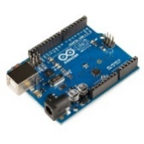

**Relay module:**

A relay module is an electronic device that contains one or more relays. Relays are electrical switches that are controlled by an input signal and can be used to switch high voltage or high current loads with a low voltage or low current signal**.** 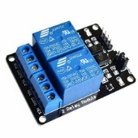

**IR Sensor:**IR sensors, also known as infrared sensors, are devices that detect and measure infraredradiation. 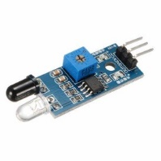

**Jumper Wires-**

Jumper wires are used to connect the various components of the whole Automatic supply power.

**Battery:**

A battery is an electrochemical device that converts stored chemical energy into electrical energy.

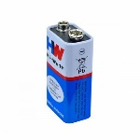

**How it works:**

The anti-accident sensor using spects eye sensor works by using sensors placed on the frames of the glasses. These sensors are designed to detect any potential danger in the user's surroundings. When a potential danger is detected, the sensors send a signal to the user through an alarm system located in the glasses.

The alarm system is designed to alert the user of the potential danger in their surroundings. The alarm system can be customized to suit the user's needs. For example, the alarm can be set to vibrate or emit a sound depending on the user's preference.

**Benefits:**

The anti-accident sensor using spects eye sensor has numerous benefits. It can help reduce accidents in hazardous work environments, which can save lives and reduce medical costs. It can also help visually impaired individuals navigate their surroundings safely, which can improve their quality of life.

In addition, this technology can help increase productivity in industries by reducing downtime caused by accidents. It can also help improve safety regulations by providing real-time data on potential hazards in the workplace.

**Chapter4: Methodology**

* In this project we are using Arduino uno Ir sensor, dual channel relay, and some jumper wires

* In Ir sensor consist of 5v out gnd were 5v is connected to 5v in Arduino uno board and out pin was connected to 2nd digital pin of Arduino uno board and gnd was connect to gnd pin of Arduino uno board

* And dual channel relay consist of (GND, INI2, INI1, VCC) were gnd is connected to gnd pin of Arduino uno board and INI1 pin was connected to 11th digital pin of Arduino uno board vcc connected to vcc pin of Arduino uno board

* And make a general connection of gear motor with an 9v battery and connect positive and passing wire which is connected to motor and make sure that wires are properly connected to relay module

5.Connect relay module to Arduino uno board with pins of 12th digital pin of ICI1, GND AND VCC pin to vcc and gnd pin of Arduino uno board .

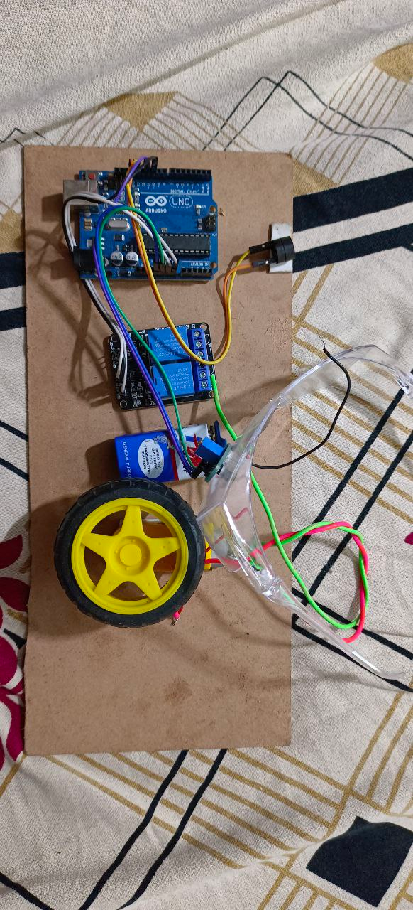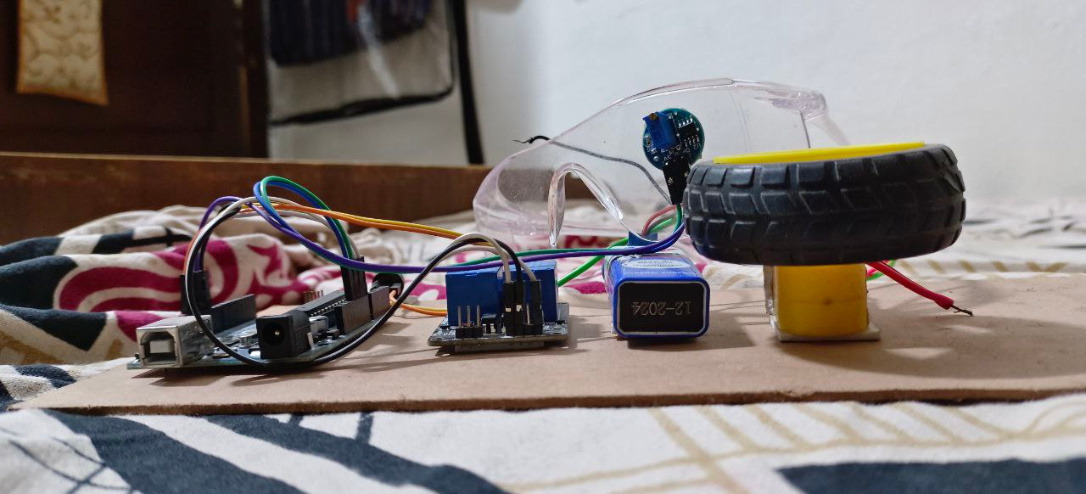

**Chapter5: Theoretical Analysis**

The theoretical analysis for anti-sleeping glasses for divers would involve considering several factors such as the type of light used, the intensity and duration of the light, and the potential effects on the diver's visual system and performance.

One of the key considerations for anti-sleeping glasses for divers is the type of light used. Research has shown that blue light, in particular, has a stimulating effect on the brain and can help to promote alertness and wakefulness. Therefore, anti-sleeping glasses may use blue LED lights to emit a specific wavelength of light that is most effective for keeping divers awake.

Another important factor to consider is the intensity and duration of the light. The glasses would need to emit a bright enough light to stimulate the brain but not so bright that it impairs the diver's vision or causes discomfort. Additionally, the glasses would need to be designed to turn off automatically after a certain period to prevent overstimulation or potential damage to the diver's visual system.

It is also important to consider the potential effects on the diver's visual system and performance. Prolonged exposure to bright lights can cause eye strain, fatigue, and even temporary blindness. Therefore, the glasses would need to be designed to minimize any potential negative effects on the diver's vision and performance.

Overall, the theoretical analysis for anti-sleeping glasses for divers would involve careful consideration of factors such as the type of light used, intensity and duration of the light, and potential effects on the diver's visual system and performance. Proper design and testing would be necessary to ensure that the glasses are effective in promoting wakefulness and do not cause harm to the diver.

**Circuit Diagram:**

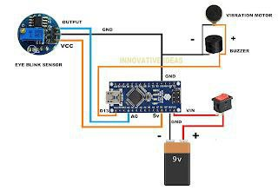

**Code:**

const int sensor Pin = A0; // connect the IR sensor to analog pin A0

const int relay Pin = 2; // connect the relay module to digital pin 2

void setup () {

pin Mode (sensor Pin, INPUT);

pin Mode (relay Pin, OUTPUT);

digital Write (relay Pin, LOW); // turn off the relay by default

}

void loop () {

int sensor Value = analog Read (sensor Pin);

if (sensor Value < 100) { // adjust the threshold value based on your sensor and environment

digital Write (relay Pin, HIGH); // activate the relay output

delay (1000); // wait for 1 second

digital Write (relay Pin, LOW); // deactivate the relay output

}

Delay (10); // wait for 10ms before reading the sensor again

}

**Chapter6: Conclusion**

In conclusion, the anti-accident sensor using spects eye sensor is an innovative technology that has numerous applications in various industries. It can help reduce accidents, increase productivity, and improve safety regulations. While this technology faces some challenges, its benefits far outweigh the challenges.

As technology continues to advance, we can expect to see more innovations like the anti-accident sensor using spects eye sensor that will help us prevent accidents and improve safety in our daily lives.

**Chapter7: References**

JINS MEME: These glasses are equipped with sensors that can detect eye movement and fatigue levels. They can then send alerts to the driver's smartphone or smartwatch, reminding them to take a break or switch drivers.

opt alert: This company makes glasses that measure eyelid movements to detect when a driver is becoming drowsy. The glasses can then alert the driver with an audible alarm or vibration.

No Nap: These glasses use a combination of sensors and algorithms to detect signs of fatigue in drivers. They can then sound an alarm or vibrate to wake the driver up.

Smart Cap: While not technically glasses, Smart Cap is a wearable device that drivers can wear under their hats or helmets. It measures brainwave activity to detect signs of fatigue and can send alerts to the driver's supervisor or fleet manager.